The Offset-Generator

Suck energy from the void!

User Manual by Adrian

1. The Components
2. Setup
3. Disassemble
4. Fuel
5. Troubleshooting / Important Notes
6. Terms of use

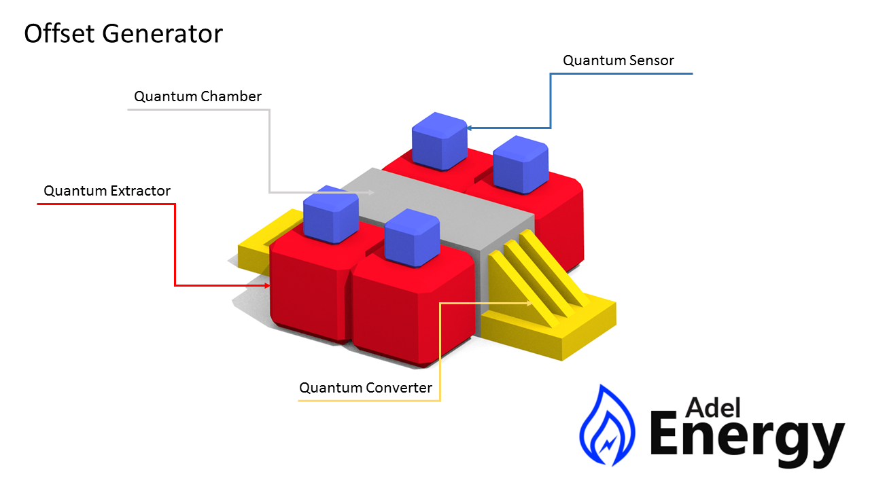

1. The Components

1. Quantum Sensor
2. Quantum Extractor
3. Quantum Chamber
4. Quantum Converter
5. The Quantum Sensor search for quantic shifts. When it finds gabs it send the data to the Extractor.
6. The Extractor collect quantic energy from the destination the sensor has given. From there the energy will be send into the Quantum Chamber.

1. The Quantum Chamber storage this energy and hold it ready to be converted by the Quantum Converter. If the chamber runs empty it will have a burnout.
2. The Quantum Converter converts the energy from the chamber into electricity. It also owns a emergency shutdown switch. There are only two slots for converter.

2. Setup

The setup is very difficult and it is recommend to read the Manual carefully and to use non-conductive gloves. Also an unexperienced engineer should not do this process.

The core of the machine is the Quantum Chamber. Place this part where the center of the machine should be screw the chamber on the floor for more security. Next connect the Quantum Converter on the ends of the chamber. Don’t connect them to your electricity network yet! Now you need to add the four Quantum Extractors to the Quantum Chamber. Place them on the sides and wrench them to the Chamber. On top of the Extractors is a port for the Quantum Sensors. Connect the Sensors to the Extractors. The construction should be look like the picture on the front page of this manual.

To power up the machine, fill the Extractors with a quantum breaking material. Then supply the Extractors with energy and turn them on. The Sensors get their energy from the Extractors and activate automatically with the booting of the extractors. Make sure the Converters are not connected to the main Energy system. Else the chamber burn out! After the successfully supply of the extractor, you need to wait a few seconds. When the extractors have an output of 50% you can safely connect the Converter to your main power system. Turn on the Converter and pull the emergency stop switch on the converter and chamber off.

Optional for more safety you can wrench the Sensors on the extractors.

3. Disassemble

Before you start the process make sure you wear non-conductive gloves.

To disassemble this thing you need at first to switch every emergency switch on. Cut the Quantum Converter from your main power system. Remove the Sensors from the Extractors and then the Extractors from the Quantum Chamber. Also remove the Quantum Converter.

Before removing the chamber, cool it down to 20° kelvin. Empty the machine with a Bucket on the ports for the converters. Don’t worry, the cold liquid isn’t dangerous. Maybe it can destroy your skin on contact. When the chamber is empty you can start unscrewing the chamber from the floor.

4. Fuel

You can put different materials in the Extractors to get another efficiency. More efficiency means more output and you can generate more energy with the Converters. The machine don’t reduce the materials but note that they can get less because of their half-life.

For some materials the sensor needs more power.

|  |  |  |
| --- | --- | --- |
| **Material** | **Efficiency** | **Power usage** |
| Iron | 30% | 200 kw |
| 238Uranium | 80% | 1 mw |
| 233Uranium | 90% | 1 mw |
| Supermatter | 150% | 800 kw |

5. Troubleshooting

You have a problem with your Device?

1. Your Machine explodes:

If this happens you screwed it up. Maybe you did not read the manual carefully enough!

1. No power is coming out:

Check out these points:

* Are all emergency switches are turned off?
* Have you connected everything correct?

1. You get shocked when you disassemble the device:

That’s normal. Wear non-conductive gloves!!!

Important Notes:

* You need initial energy to power up the machine. On a total blackout you can’t activate the machinery.
* Never have the chamber empty after using it. Elsewise it will burn out. Make sure there is some quantum energy left.

6. Terms of Use

1. Use the generator on your own risk. Adel Energy don’t take any responsibility for deaths, damage or else.
2. Other license blablub